

NAME: BISMA FATIMA
CLASS: CS A
ROLL NO: F24605036
COURSE: OBJECT ORIENTED PROGRAMMING
COURSE CODE: CS-123
LECTURER: MISS TAYYABA KALSOOM

LAB 03 [WEEK 03]

Task Array:
Task 1:
Write a Java program that creates a String array to store the names of 5 students. Then,
print the first student’s name.

PROGRAM
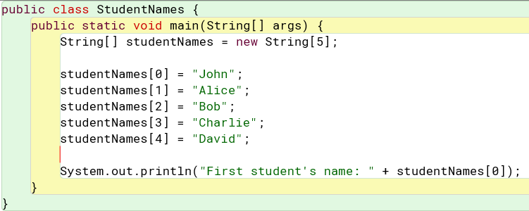

OUTPUT

Task 2:
Create an integer array to store the roll numbers of 10 students. Assign roll numbers to each student, and then print the roll number of the student at index 3.
PROGRAM
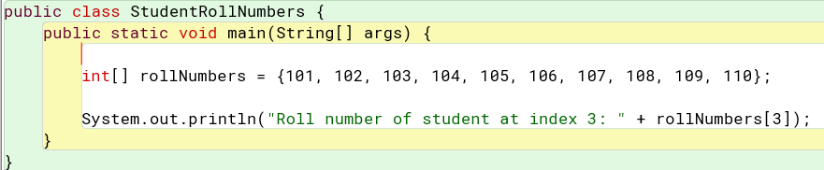

OUTPUT

Task 3:
Given a String array of student names, write a Java program to count how many students are in the list (get the length of the array).

PROGRAM
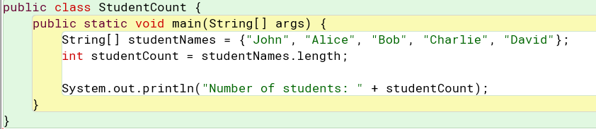

OUTPUT

Task 4:
Given an array of student grades (integers), write a java program to calculate the average grade.
PROGRAM
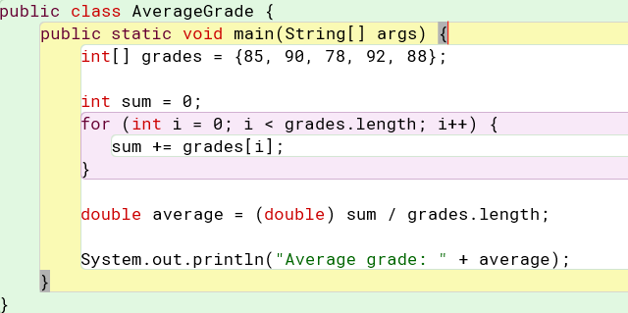

OUTPUT

Task 5:
Create a 2D integer array to represent a 3x3 matrix. Assign values to the matrix, and then calculate and print the sum of all the elements in the matrix.

PROGRAM
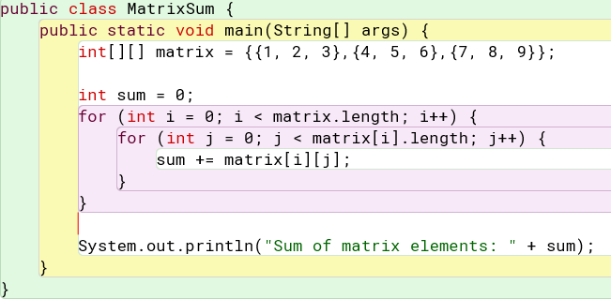

OUTPUT
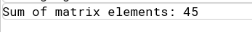

Task Class and Object

Task 1: Creating a Simple Class and Object
Objective: Learn how to define a class and create objects.
- Create a class Car with attributes: brand, model, and year.
- Create a method displayDetails() that prints the car details.
- In the main() method, create two objects of the Car class and call
displayDetails() for each.
PROGRAM
1. public class Car{
2. String brand; //attributes
3. String model;
4. int year;
5.
6. void displayDetails(){
7.
8. System.out.println("brand="+brand);
9. System.out.println("model="+model);
10. System.out.println("year="+year);
11. }
12.
13. public static void main(String[] args){
14.
15. Car car1= new Car();
16. Car car2= new Car();
17.
18.
19. car1.brand = "Toyota";
20. car1.model = "Camry";
21. car1.year = 2020;
22.
23. car2.brand = "Honda";
24. car2.model = "Civic";
25. car2.year = 2019;
26.
27. System.out.println("Car 1 Details:");
28. car1.displayDetails();
29.
30. System.out.println("\nCar 2 Details:");
31. car2.displayDetails();
33. }
34. }

OUTPUT
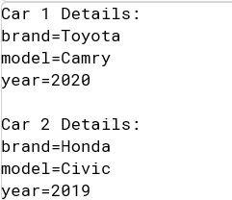

Task 2: Implementing Parameterized Constructor
Objective: Learn how to use parameterized constructors.
- Modify the Car class to include a parameterized constructor that initializes brand, model, and year.
- Create and initialize two objects using the constructor.
- Print their details.
PROGRAM
1. public class Carr{
2. // Attributes
3. String brand;
4. String model;
5. int year;
6.
7. Carr(String brand, String model, int year) {
8. this.brand = brand;
9. this.model = model;
10. this.year = year;
11. }
12.
13. void displayDetails() {
14. System.out.println("Brand: " + brand);
15. System.out.println("Model: " + model);
16. System.out.println("Year: " + year);
17. }
18.
19. public static void main(String[] args) {
20.
21. Carr car1 = new Carr("Toyota", "Camry", 2020);
22. Carr car2 = new Carr("Honda", "Civic", 2019);
23.
24. System.out.println("Car 1 Details:");
25. car1.displayDetails();
26.
27. System.out.println("\nCar 2 Details:");
28. car2.displayDetails();
29. }
30. }
31.

OUTPUT
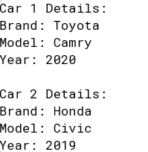

Task 3: Default and Parameterized Constructors
Objective: Understand the difference between default and parameterized constructors.
- Create a class Student with attributes: name, rollNo, and grade.
- Implement:
o A default constructor that initializes values to Unknown, 0, and N/A.
o A parameterized constructor that initializes all attributes with given
values.
- In main(), create two objects: one using the default constructor and one using the
parameterized constructor. Display their details.
PROGRAM
1. public class Student {
2. // Attributes
3. String name;
4. int rollNo;
5. String grade;
6. Student() {
7. name = "Unknown";
8. rollNo = 0;
9. grade = "N/A";
10. }
11. Student(String name, int rollNo, String grade) {
12. this.name = name;
13. this.rollNo = rollNo;
14. this.grade = grade;
15. }
16. void displayDetails() {
17. System.out.println("Name: " + name);
18. System.out.println("Roll No: " + rollNo);
19. System.out.println("Grade: " + grade);
20. }
21. public static void main(String[] args) {
22. Student student1 = new Student();
23. Student student2 = new Student("John Doe", 123, "A");
24. System.out.println("Student 1 Details:");
25. student1.displayDetails();
26. System.out.println("\nStudent 2 Details:");
27. student2.displayDetails();
28. }
29. }

OUTPUT
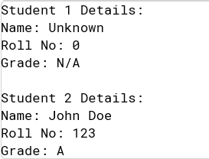
Task 4: Create a Rectangle Class with
Attributes – length and width
Constructor – to initialize the attributes
Methods – calArea(length, width), calPerimeter(length, width)
calArea(length, width) – Calculate the area of the rectangle and display it
calPerimeter(length, width) – Calculate the perimeter of the rectangle and display it
Write main method to check the functionality of the class

PROGRAM
1. public class Rectangle {
2. // Attributes
3. int length;
4. int width;
5.
6. Rectangle(int length, int width) {
7. this.length = length;
8. this.width = width;
9. }
10.
11. void calArea() {
12. int area = length * width;
13. System.out.println("Area: " + area);
14. }
15.
16. void calPerimeter() {
17. int perimeter = 2 * (length + width);
18. System.out.println("Perimeter: " + perimeter);
19. }
20.
21. public static void main(String[] args) {
22.
23. Rectangle rectangle = new Rectangle(10, 5);
24.
25. System.out.println("Rectangle Details:");
26. rectangle.calArea();
27. rectangle.calPerimeter();
28. }
29. }
30.

OUTPUT
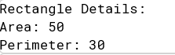
Task 5: Create an Employee Class with
• Attributes – name, salary, hours of work
• Constructor – to initialize the attributes
• Methods – showInfo(), addToSalary(amount), deductFromSalary(amount)
• showInfo() – display whole information of Employee
• addToSalary(amount) – increase salary by 20% if hours of work is greater than 8
• deductFromSalary(amount) – deduct 5% if hours of work is less than 5
• Write main method to check the functionality of the class

Program
1. public class Employee {
2.
3. String name;
4. double salary;
5. int hoursOfWork;
6.
7. Employee(String name, double salary, int hoursOfWork) {
8. this.name = name;
9. this.salary = salary;
10. this.hoursOfWork = hoursOfWork;
11. }
12.
13. void showInfo() {
14. System.out.println("Name: " + name);
15. System.out.println("Salary: " + salary);
16. System.out.println("Hours of work: " + hoursOfWork);
17. }
18.
19. void addToSalary(double amount) {
20. if (hoursOfWork > 8) {
21. salary += amount * 0.2;
22. System.out.println("Salary increased by 20%");
23. } else {
24. System.out.println("No salary increase");
25. }
26. }
27.
28. // Method to deduct 5% if hours of work is less than 5
29. void deductFromSalary(double amount) {
30. if (hoursOfWork < 5) {
31. salary -= amount * 0.05;
32. System.out.println("Salary deducted by 5%");
33. } else {
34. System.out.println("No salary deduction");
35. }
36. }
37.
38. public static void main(String[] args) {
39. Employee employee = new Employee("John Doe", 5000, 10);
40.
41. System.out.println("Employee Information:");
42. employee.showInfo();
43.
44. employee.addToSalary(1000);
45.
46. System.out.println("\nUpdated Employee Information:");
47. employee.showInfo();
48.
49. employee.deductFromSalary(1000);
50. System.out.println("\nUpdated Employee Information:");
51. employee.showInfo();
52. }
53. }

OUTPUT
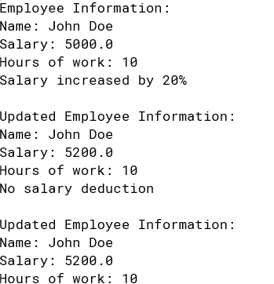

Task 6: Create an Account Class with
Attributes – name and balance
Constructor – to initialize the attributes
Methods – displayInfo(), deposit(amount), withdraw(amount)
displayInfo() – Display the account holder’s name and current balance
deposit(amount) – Add the specified amount to the account balance and display the
updated balance
withdraw(amount) – Check if the account has sufficient funds to withdraw the specified
amount. If there are enough funds, withdraw the amount and display the remaining balance.
If there are insufficient funds, display a message indicating so
Write main method to check the functionality of the class.

PROGRAM
1. public class BankAccount {
2. // Attributes
3. String name;
4. double balance;
5.
6. // Constructor to initialize the attributes
7. BankAccount(String name, double balance) {
8. this.name = name;
9. this.balance = balance;
10. }
11.
12. // Method to display account holder's name and current balance
13. void displayInfo() {
14. System.out.println("Account Holder: " + name);
15. System.out.println("Current Balance: " + balance);
16. }
17.
18. // Method to add specified amount to the account balance
19. void deposit(double amount) {
20. balance += amount;
21. System.out.println("Deposit Amount: " + amount);
22. System.out.println("Updated Balance: " + balance);
23. }
24.
25. // Method to withdraw specified amount from the account
26. void withdraw(double amount) {
27. if (balance >= amount) {
28. balance -= amount;
29. System.out.println("Withdrawal Amount: " + amount);
30. System.out.println("Remaining Balance: " + balance);
31. } else {
32. System.out.println("Insufficient Funds");
33. }
34. }
35.
36. // Main method to check the functionality of the class
37. public static void main(String[] args) {
38. // Create a BankAccount object
39. BankAccount account = new BankAccount("John Doe", 1000.0);
40.
41. // Display account information
42. System.out.println("Account Information:");
43. account.displayInfo();
44.
45. // Deposit amount
46. account.deposit(500.0);
47.
48. // Withdraw amount
49. account.withdraw(200.0);
50.
51. // Withdraw amount with insufficient funds
52. account.withdraw(2000.0);
53. }
54. }

OUTPUT
